CSE 344 – Systems Programming
Homework #4 Report
Multi-Process & Multi-Threaded Concurrent Log Analysis Pipeline

Student Name: FATİH EMRE OĞAN
Student ID: 230104004090
Course: CSE 344 – Systems Programming
Date: April 2026

Table of Contents
Table of Contents 2
1. Introduction 3
2. System Architecture 4
3. Shared Memory Layout 6
Region A — Dispatcher Input Queue 6
Region B — Per-Level Analysis Buffers (×4) 6
Region C — Results Area 6
Region D — High-Priority Buffer 7
4. Lock Ordering and Deadlock Prevention 8
5. Thread Lifecycle 9
Reader Thread Lifecycle 9
Worker Thread Lifecycle (Analyzer Process) 9
6. TLS Design 10
Why flush in the destructor, not at the barrier? 10
7. Dispatcher Logic 11
8. Termination Chain 12
9. Challenges & Solutions 13
Challenge 1: TLS Flush Timing 13
Challenge 2: Dispatcher Timeout with eof_count_per_level 13
Challenge 3: Overlapping Keyword Search 13
10. Test Scenarios 14
Test 1 — Baseline 14
Test 2 — Multi-keyword 16
Test 3 — Single Thread 17
Test 4 — High Concurrency (Determinism Check) 18
Test 5 — No Priority Matches 20
Test 6 — Valgrind 21
Test 7 — Ctrl+C Handling 22

1. Introduction
This report documents the design and implementation of a Concurrent Log Analysis Pipeline developed for CSE 344 – System Programming, Homework #4. The system processes multiple log files simultaneously using a multi-process and multi-threaded architecture in C on a POSIX-compatible Linux environment.

The pipeline consists of seven distinct process and thread types working in concert: Reader Processes parse log files concurrently, a Dispatcher Process routes entries to level-specific buffers, four Analyzer Processes perform keyword-weighted scoring, an Aggregator Process produces structured output files, and a Watchdog Thread provides live progress reporting. All inter-process communication is performed through shared memory regions protected by process-shared POSIX primitives.

The main challenges addressed in this implementation include:
- Correctly ordering lock acquisitions across four shared memory regions to avoid deadlock.
- Using thread-local storage (pthread_key_t) for per-thread keyword score accumulation, with flushing deferred to the TLS destructor rather than the barrier.
- Implementing overlapping keyword search using a sliding-window algorithm.
- Handling multiple EOF markers from multiple Reader Processes in the Dispatcher without races.
- Ensuring atomic output file creation using rename(2) on a temporary file.
- Clean SIGINT handling with async-signal-safe operations only inside the signal handler.

2. System Architecture
The system comprises the following process and thread types:
- Parent / Coordinator Process — Initializes shared memory, forks all children, starts Watchdog Thread, waits for children.
- Reader Process (×N) — One per log file. Spawns T reader threads and 1 parser thread. Writes heartbeats to a dedicated pipe.
- Dispatcher Process (×1) — Reads from Region A, routes entries to Region B (per-level) and Region D (high-priority).
- Analyzer Process (×4) — One per severity level. Spawns W worker threads using TLS for score accumulation.
- Aggregator Process (×1) — Waits for all Region C results, writes text and binary output files.
- Watchdog Thread — Runs inside the parent, reads heartbeat pipes via select(), prints progress to stderr every 3 seconds.
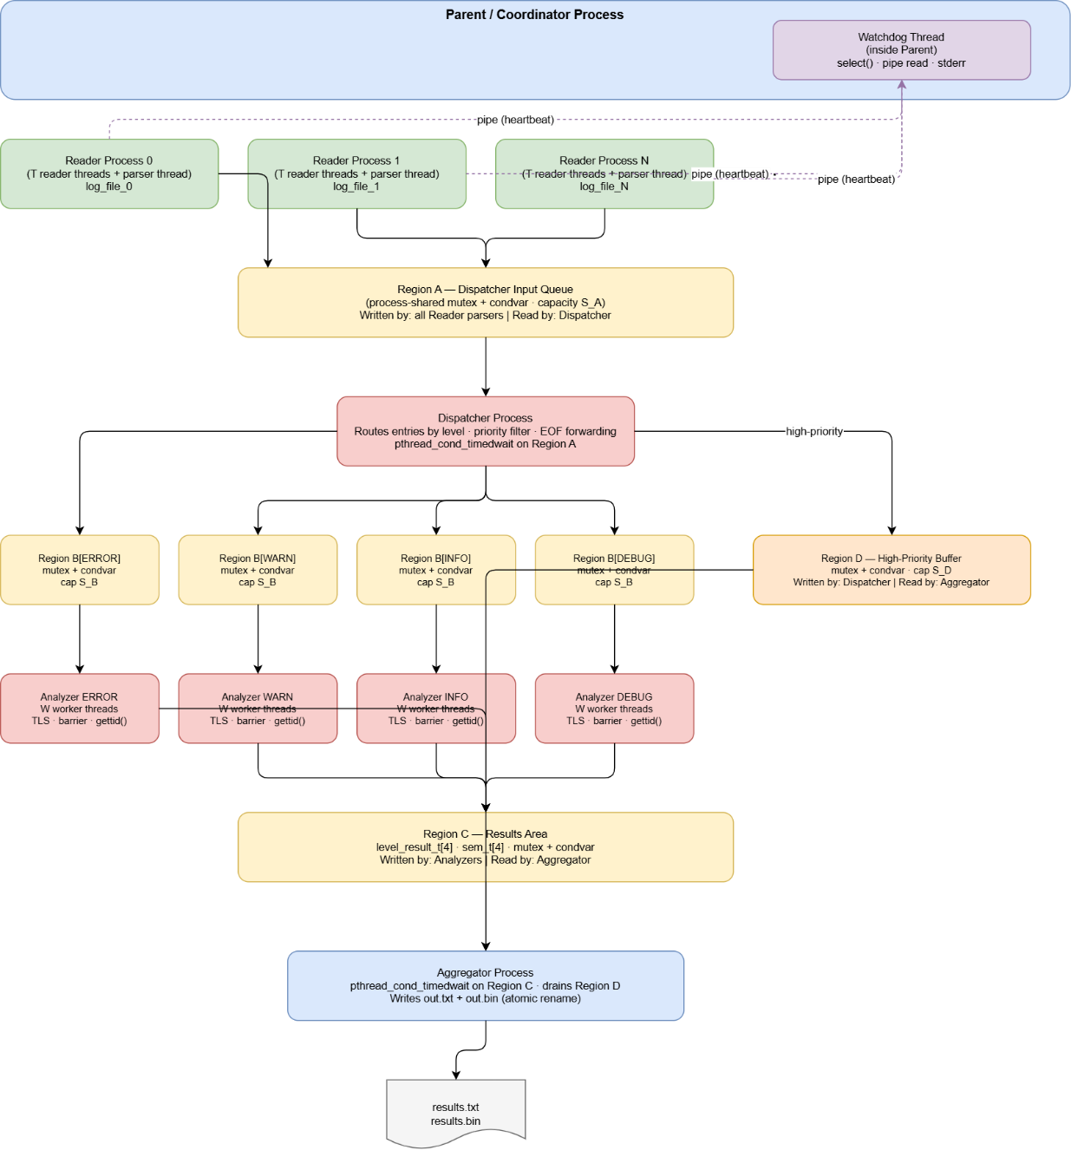

3. Shared Memory Layout
Four shared memory regions are created by the parent using mmap(MAP_SHARED|MAP_ANONYMOUS) before any fork. All mutexes and condition variables use PTHREAD_PROCESS_SHARED attribute.

Region A — Dispatcher Input Queue
A single circular buffer of log_entry_t fed by all Reader Processes and consumed by the Dispatcher.
pthread_mutex_t input_mutex; // protects all Region A fields
pthread_cond_t not_full_a; // Readers block when buffer is full
pthread_cond_t not_empty_a; // Dispatcher blocks when buffer is empty
int eof_count_per_level[4]; // incremented by each parser thread
int total_readers; // set by parent before fork
int count, head, tail; // circular buffer state
log_entry_t buf[capacity_a]; // flexible array member

Region B — Per-Level Analysis Buffers (×4)
Four independent circular buffers, one per severity level (ERROR, WARN, INFO, DEBUG). Written only by the Dispatcher; read only by the corresponding Analyzer Process.
pthread_mutex_t level_mutex; // protects this level's buffer
pthread_cond_t not_full_b; // Dispatcher blocks when full
pthread_cond_t not_empty_b; // Analyzer workers block when empty
int eof_posted; // set to 1 by Dispatcher for this level
int count, head, tail;
log_entry_t buf[capacity_b];

Region C — Results Area
Holds one level_result_t per severity level, written by the reporting thread of each Analyzer Process after the barrier. Also contains four semaphores (one per level) and a process-shared condvar for the Aggregator's timed wait.
level_result_t results[4]; // written by Analyzer reporting threads
pthread_mutex_t result_mutex; // protects results[] and results_ready
pthread_cond_t result_cond; // Aggregator waits here
int results_ready; // bitmask: bit i set when level i done
sem_t level_sem[4]; // posted by each Analyzer on completion

Region D — High-Priority Buffer
A circular buffer populated by the Dispatcher with copies of entries whose SOURCE matches the priority filter. Drained by the Aggregator in a background thread.
pthread_mutex_t priority_mutex; // protects Region D
pthread_cond_t not_full_d; // Dispatcher blocks when full
pthread_cond_t not_empty_d; // Aggregator drain thread blocks when empty
int dispatcher_done; // set by Dispatcher when finished
double high_priority_score; // written by Aggregator after drain
int count, head, tail;
log_entry_t buf[capacity_d];

4. Lock Ordering and Deadlock Prevention
A strict global lock acquisition order is enforced throughout the entire system to prevent circular dependencies:

Priority | Mutex | Purpose
1st | Region A — input_mutex | Acquired first; released before any other lock is taken
2nd | Region B — level_mutex[i] | Acquired only after releasing Region A mutex
3rd | Region C — result_mutex | Acquired only after releasing Region B mutex
4th | Region D — priority_mutex | Acquired only after releasing all other mutexes

No circular dependency exists because the ordering is strictly linear: A → B → C → D. No code path ever acquires a lower-ranked mutex while holding a higher-ranked one. Additionally, no blocking I/O is performed while any mutex is held — all file operations and pipe writes occur exclusively outside of critical sections.

The Dispatcher is the only process that writes to both Region B and Region D. It always releases the Region A mutex before acquiring either Region B or Region D mutex, and never holds Region B and Region D simultaneously. The Aggregator only acquires Region C and Region D locks independently, never together.

5. Thread Lifecycle

Reader Thread Lifecycle
- Creation: pthread_create() called by the Reader Process main function. Each thread receives a byte-range [start, end) of the log file.
- Work loop: Opens the file, seeks to range_start (skipping partial lines if not the first thread), reads lines with fgets(), parses each line, and pushes valid log_entry_t structs into the internal bounded circular buffer using pthread_mutex_t + pthread_cond_t.
- Heartbeat: After every 50 lines processed, writes a heartbeat message to the dedicated pipe using write(2) (async-signal-safe).
- Termination: When the byte range is exhausted or EOF is reached, the thread decrements ibuf.writers under the internal mutex. If it is the last writer, it sets ibuf.done = 1 and broadcasts on not_empty to wake the parser thread.
- Joined by: The Reader Process main function joins all reader threads before joining the parser thread.

Worker Thread Lifecycle (Analyzer Process)
- Creation: pthread_create() called by analyzer_process_main(). Each worker receives a worker_arg_t with its index and a pointer to the shared analyzer state.
- TLS setup: Immediately after start, the worker allocates a tls_val_t on the heap and calls pthread_setspecific(tls_key, tv) to register it as its thread-local value.
- Work loop: Locks Region B level_mutex, waits on not_empty_b with pthread_cond_wait(), pops one log_entry_t, releases the lock, counts overlapping keyword occurrences in the message using a sliding window, and accumulates weighted scores into the TLS array.
- Barrier: After the work loop exits (eof_posted == 1 and count == 0), the thread calls pthread_barrier_wait(). All W workers block here until the last one arrives.
- Reporting: After the barrier, the thread with the lowest system TID (obtained via syscall(SYS_gettid)) is selected as the reporting thread. It waits for all TLS destructors to run (guaranteed after pthread_join returns) and then writes the aggregated results to Region C under result_mutex.
- TLS Destructor: When the thread exits (returns from the thread function), the pthread runtime calls tls_destructor(). This function flushes the per-keyword scores from the TLS array into the shared per_thread_scores[][] array under local_mutex, then frees the heap allocation.
- Joined by: The Analyzer Process main function joins all worker threads. Only after all joins complete are the TLS destructors guaranteed to have run.

6. TLS Design
Each Analyzer Process creates a single pthread_key_t (tls_key) with a destructor function registered at process startup:
pthread_key_create(&tls_key, tls_destructor);

Each worker thread allocates a heap-allocated tls_val_t structure containing a per-keyword score array and its worker index, then registers it:
tls_val_t *tv = calloc(1, sizeof(tls_val_t));
tv->worker_idx = widx;
tv->shared = &sh;
pthread_setspecific(tls_key, tv);

During the work loop, keyword scores are accumulated exclusively into tv->scores[] without any locking — this is safe because TLS data is private to each thread.

The destructor function is called automatically by the pthread runtime when the thread exits:
static void tls_destructor(void *val) {
tls_val_t *tv = (tls_val_t *)val;
pthread_mutex_lock(&tv->shared->local_mutex);
for (int k = 0; k < num_keywords; k++)
sh->per_thread_scores[tv->worker_idx][k] += tv->scores[k];
pthread_mutex_unlock(&tv->shared->local_mutex);
free(val);
}

Why flush in the destructor, not at the barrier?
The pthread barrier guarantees that all threads have finished their work loops before any continues past the barrier. However, the TLS destructor is called after the thread function returns — after the barrier. If the flush were performed at the barrier, the reporting thread would need to read from other threads' TLS, which is impossible (TLS is private). By flushing in the destructor and joining all threads before reading the aggregated scores, the Analyzer Process main function can safely access per_thread_scores[][] only after all joins complete, guaranteeing all destructors have run.

7. Dispatcher Logic
The Dispatcher Process is the sole consumer of Region A and the sole producer of Region B and Region D. It runs a single loop until all EOF markers for all levels have been forwarded to Region B.

EOF marker handling across multiple Reader Processes:
- Each Reader Process has one parser thread. After all log entries are pushed to Region A, the parser thread sends one EOF marker per severity level (4 total per Reader Process). Simultaneously, it increments ra->eof_count_per_level[lvl] under the Region A mutex for each level.
- The Dispatcher maintains eof_observed[4] — a counter per level of how many EOF markers it has seen from Reader Processes. When eof_observed[lvl] reaches total_readers, the Dispatcher knows all readers have finished sending entries for that level.
- At that point, it pushes a single EOF marker for that level into Region B[lvl] and sets eof_forwarded[lvl] = 1. Worker threads in the Analyzer Process for that level detect eof_posted == 1 and exit their work loops.
- The main loop exits when all four levels have eof_forwarded set.

Timed wait: The Dispatcher uses pthread_cond_timedwait on not_empty_a with a configurable timeout (default 10 seconds). On timeout, it checks whether ra->eof_count_per_level[l] >= total_readers for all levels. If so, it exits immediately. Otherwise it refreshes the deadline and retries. This prevents the Dispatcher from blocking indefinitely if a Reader Process crashes.

Priority routing: For each non-EOF entry, the Dispatcher checks if entry.source appears in the loaded priority source list. If yes, the entry is pushed to both Region B[lvl] and Region D. The single-writer constraint (only the Dispatcher writes to B and D) eliminates the need for additional inter-process coordination on these regions.

8. Termination Chain
Normal termination proceeds in the following strict order:

Step | Description
1 | All reader threads in every Reader Process finish their byte ranges and signal the parser thread via ibuf.done.
2 | Each parser thread sends 4 EOF markers (one per level) to Region A, incrementing eof_count_per_level[], then exits.
3 | Each Reader Process joins all its threads and calls _exit(0).
4 | The Dispatcher observes all EOF markers, forwards one EOF per level to Region B, sets rd->dispatcher_done = 1 in Region D, then calls _exit(0).
5 | Each Analyzer Process: worker threads detect eof_posted in Region B, exit work loops, hit the barrier, the reporting thread writes results to Region C under result_mutex and broadcasts result_cond, posts level_sem, then _exit(0).
6 | The Aggregator wakes from pthread_cond_timedwait when results_ready == 0xF, drain thread finishes Region D, writes text and binary output files (with atomic rename), then calls _exit(0).
7 | The parent's waitpid() loop returns. The parent sets shutdown_watchdog = 1 and calls pthread_join on the Watchdog Thread.
8 | The Watchdog Thread detects shutdown_watchdog == 1 after its next select() call and returns.
9 | The parent reads final results from Region C, prints the SYSTEM SUMMARY to stdout, calls shm_destroy() to munmap all regions and destroy all primitives, closes all pipe file descriptors, and returns 0.

9. Challenges & Solutions

Challenge 1: TLS Flush Timing
Problem: The initial design flushed TLS scores to the shared result structure at the barrier, before thread exit. This caused a race condition because the reporting thread attempted to read per_thread_scores[][] while other threads had not yet flushed their TLS data — the destructor had not run yet.

Solution: The flush was moved entirely into the pthread_key_t destructor function. The Analyzer Process main function now reads per_thread_scores[][] only after pthread_join() returns for all worker threads, guaranteeing all destructors have completed. This required redesigning the barrier-to-exit sequence so the reporting thread does not attempt to read shared scores until after all joins.

Challenge 2: Dispatcher Timeout with eof_count_per_level
Problem: The Dispatcher's pthread_cond_timedwait timeout fallback checked ra->eof_count_per_level[] to determine if all readers had finished. However, eof_count_per_level was never incremented — only the is_eof flag in the entry struct was used — so the timeout exit condition could never trigger.

Solution: The parser thread in each Reader Process was modified to increment ra->eof_count_per_level[lvl]++ under the Region A mutex immediately after pushing each EOF marker. This ensures the Dispatcher can correctly detect completion via the timeout path when a Reader Process finishes abnormally or when the main buffer is drained under timeout conditions.

Challenge 3: Overlapping Keyword Search
Problem: Using strstr() and advancing by the length of the keyword after each match misses overlapping occurrences. For example, searching for 'error' in 'errorerror' with strstr()-based advancement finds only 1 match instead of 2.

Solution: A manual sliding-window approach was implemented: the search pointer advances by exactly 1 character after each match (whether or not a match was found), not by the keyword length. This correctly identifies all overlapping occurrences at the cost of O(n*m) time, which is acceptable for log message lengths.
while (*p) {
if (strncmp(p, keyword, klen) == 0) { count++; }
p++; // always advance by 1, not by klen
}

10. Test Scenarios
All tests were run on Debian 12 (64-bit) in VirtualBox. Screenshots below show the complete terminal output from command prompt through program exit.

Test 1 — Baseline
Verifies correct entry counts, human-readable output format, and binary file magic number 0xC5E3440B.
make

./analyzer -c basic.conf -f filter.txt -k "error" -t 2 -w 2 -a 16 -b 16 -d 8 -T 5 -o out_t1.txt -O out_t1.bin && cat out_t1.txt

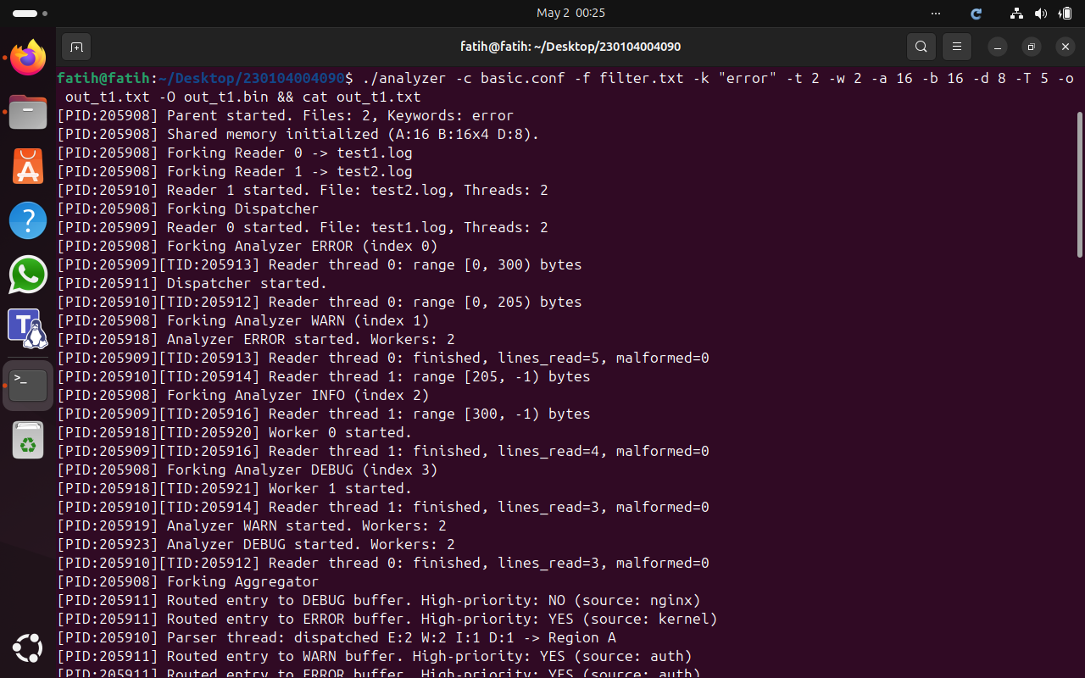
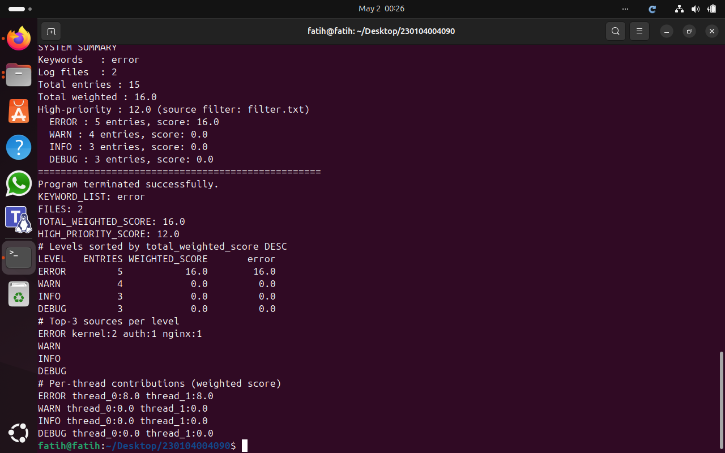

Test 2 — Multi-keyword
Verifies per-keyword score breakdown and weighted scoring across four keywords.
./analyzer -c basic.conf -f filter.txt -k "error,fail,timeout,kill" -t 2 -w 2 -a 16 -b 16 -d 8 -T 5 -o out_t2.txt -O out_t2.bin && cat out_t2.txt

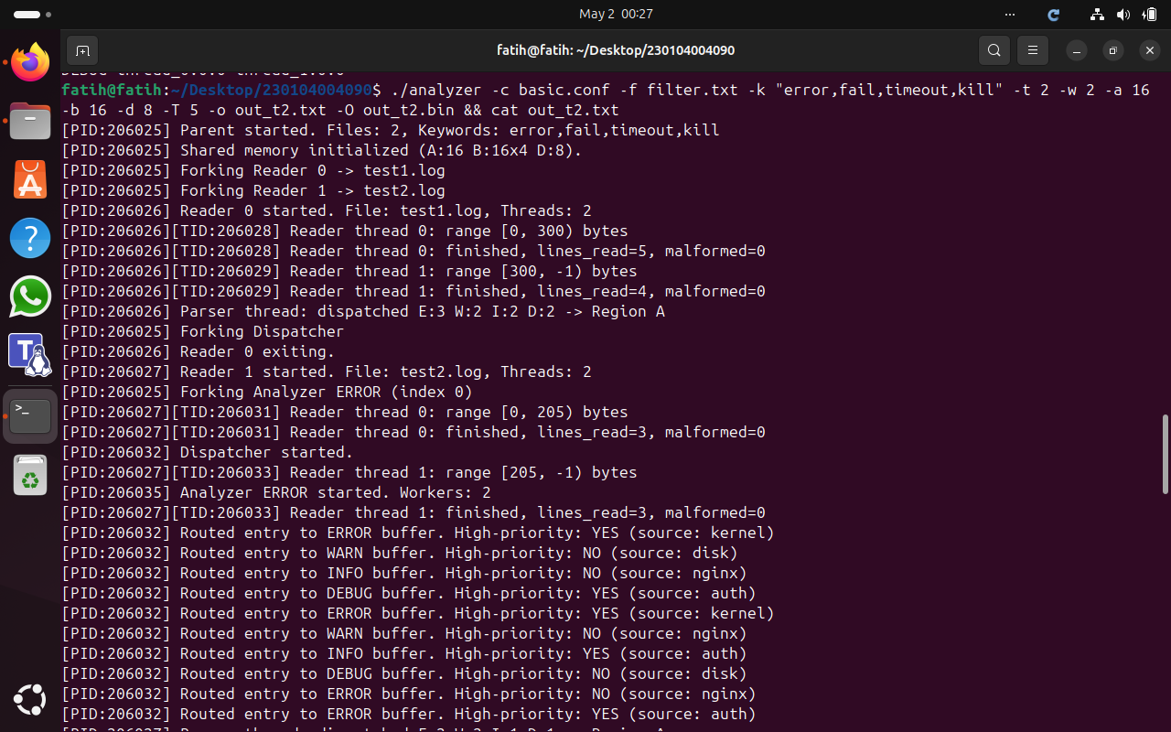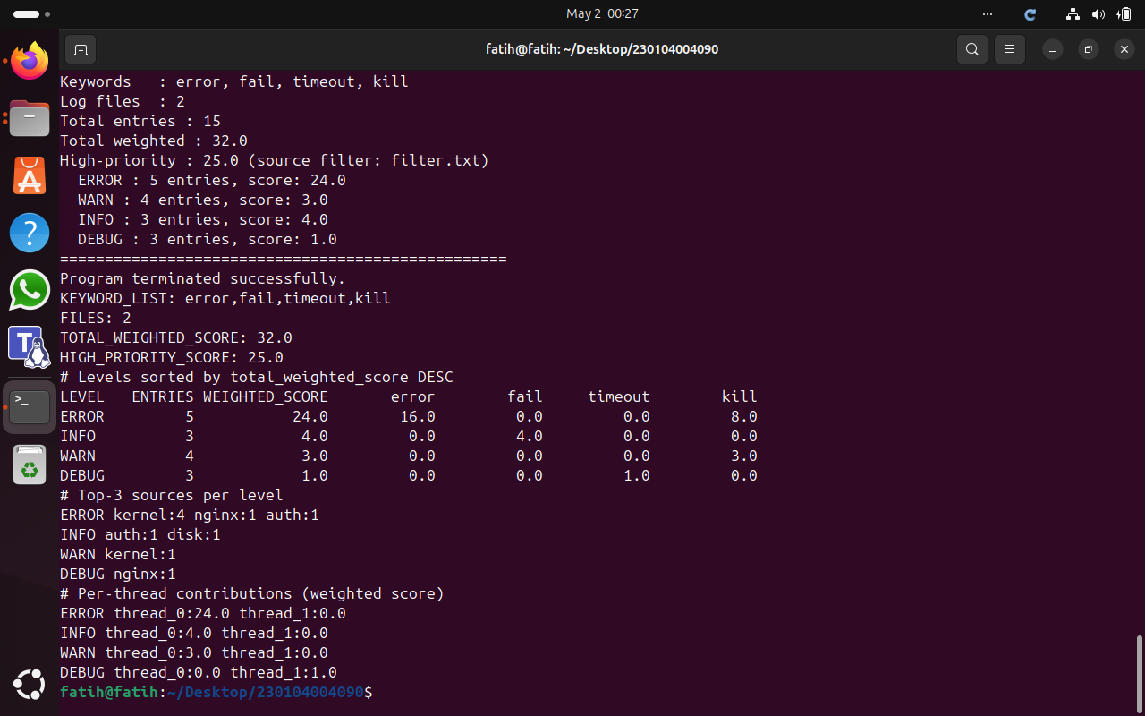

Test 3 — Single Thread
Verifies sequential correctness with t=1 w=1. Totals must match Test 1 baseline.
./analyzer -c basic.conf -f filter.txt -k "error,fail,kill" -t 1 -w 1 -a 4 -b 4 -d 2 -T 5 -o out_t3.txt -O out_t3.bin && cat out_t3.txt

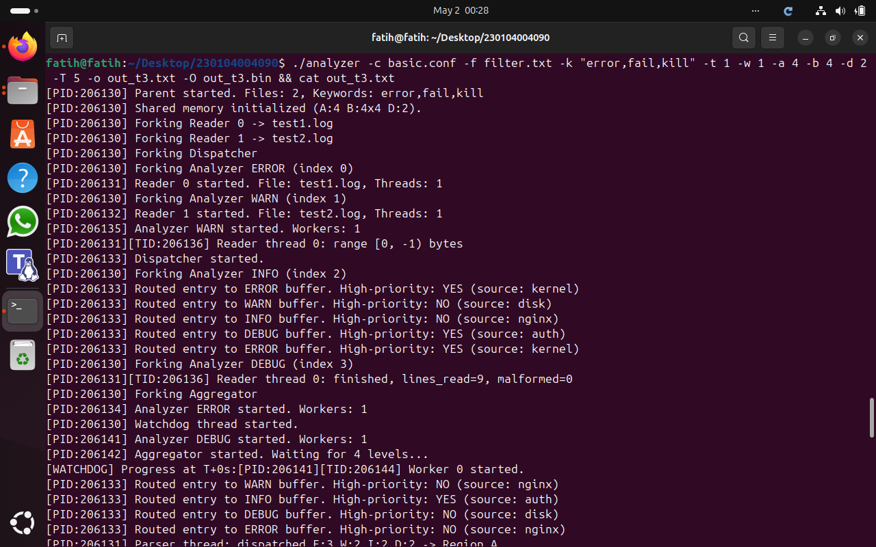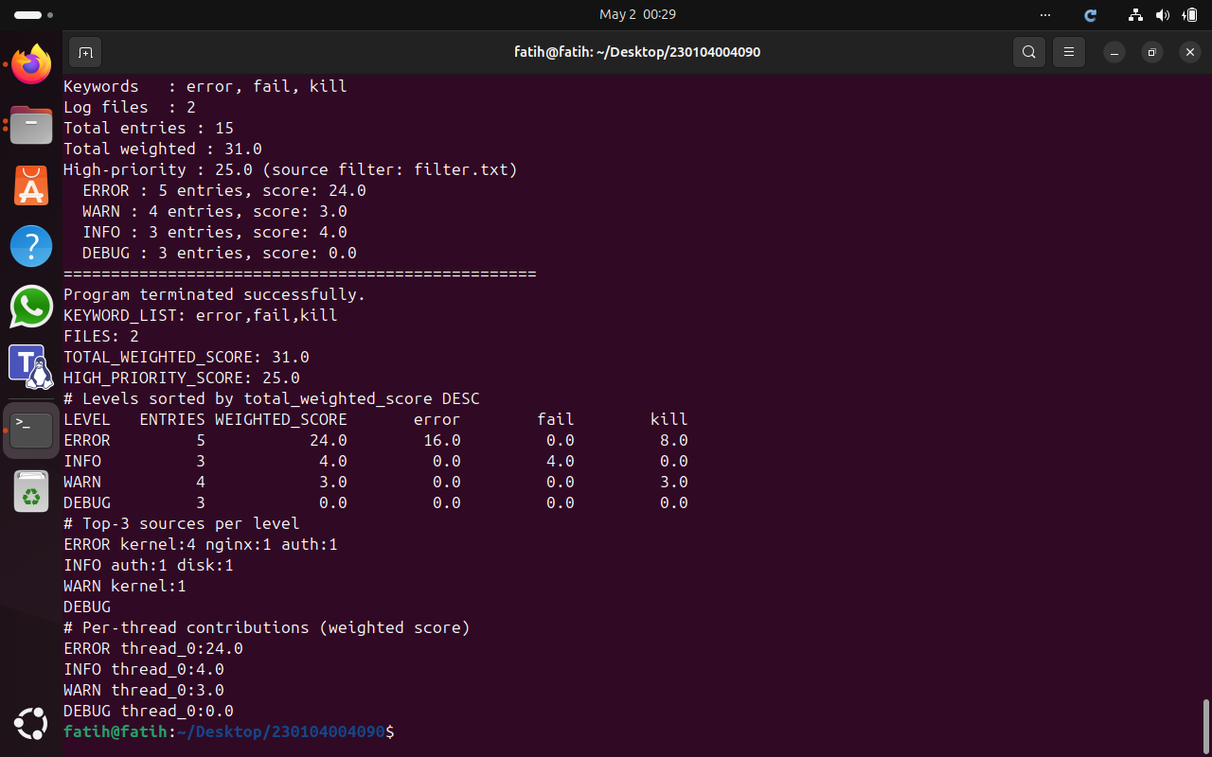

Test 4 — High Concurrency (Determinism Check)
Runs 3 times with t=8 w=6 on 600+ line log file. TOTAL_WEIGHTED_SCORE must be identical across all runs.
./analyzer -c large.conf -f filter.txt -k "error,fail,kill" -t 8 -w 6 -a 128 -b 128 -d 32 -T 10 -o out_t4.txt -O out_t4.bin && grep "TOTAL_WEIGHTED" out_t4.txt
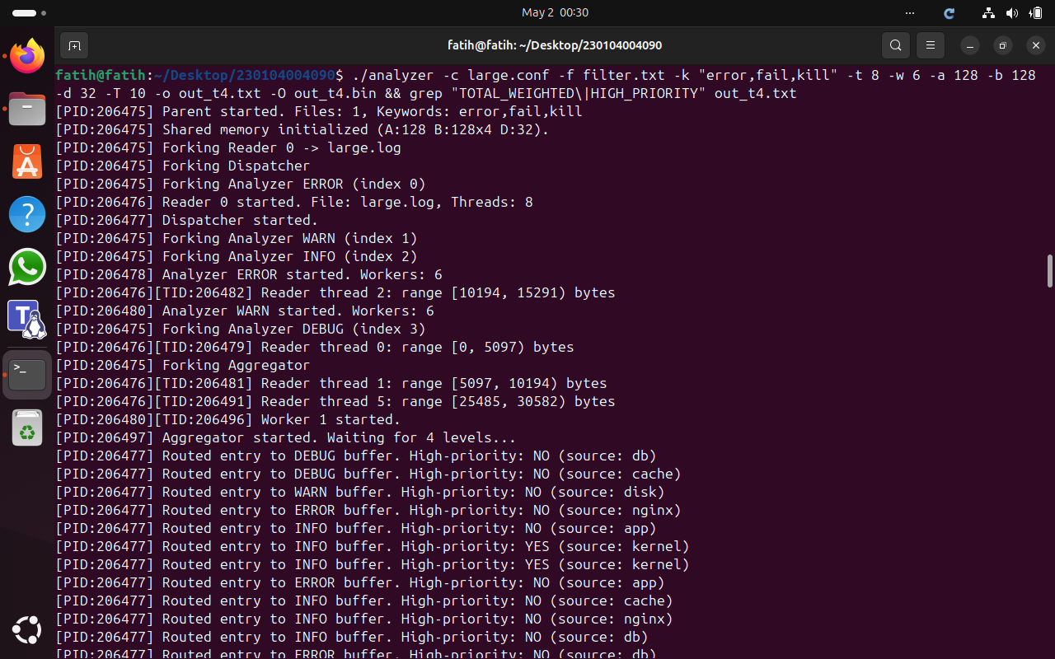

Run 1 — TOTAL_WEIGHTED_SCORE: 1038.0
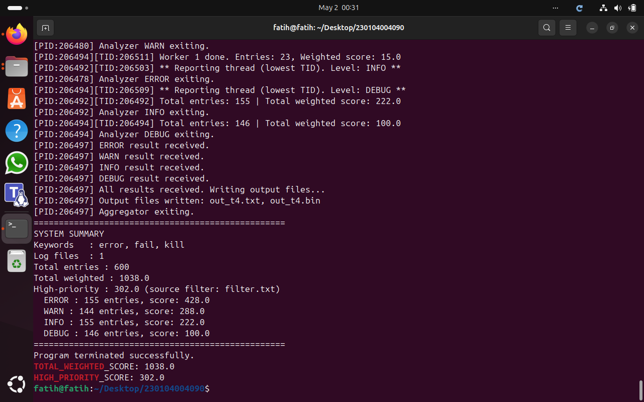

Run 2 — TOTAL_WEIGHTED_SCORE: 1038.0
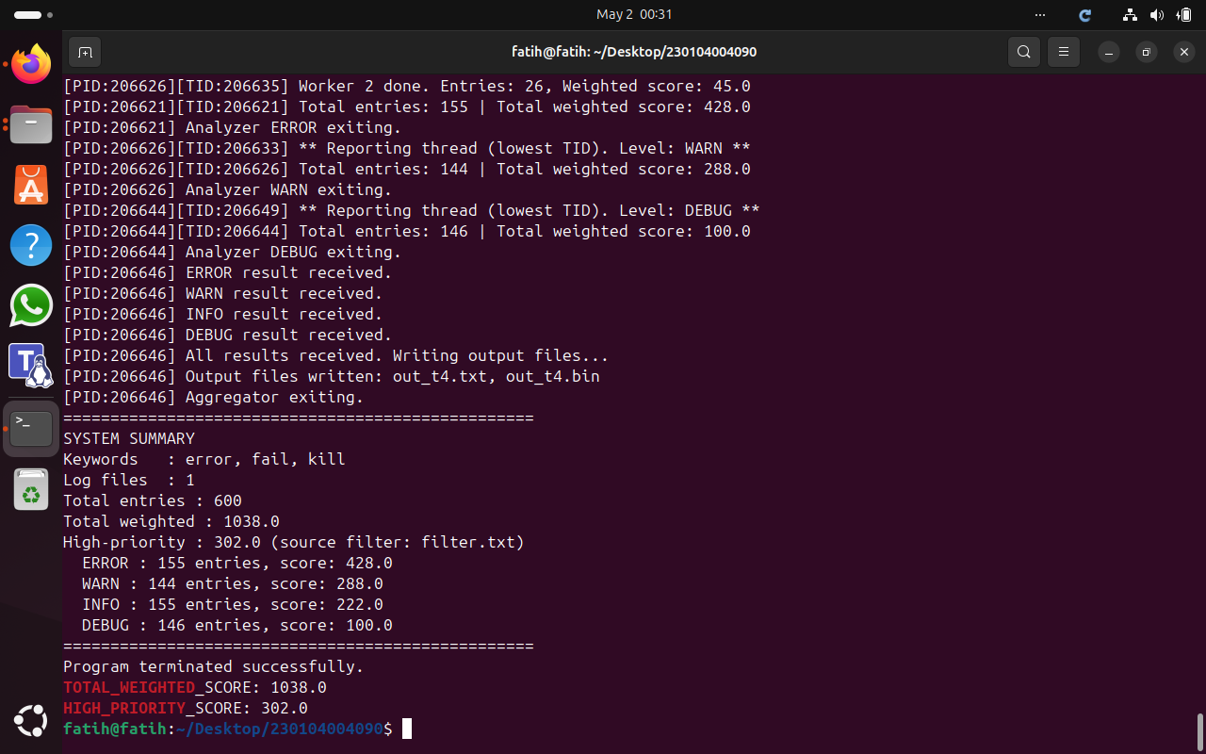
Run 3 — TOTAL_WEIGHTED_SCORE: 1038.0
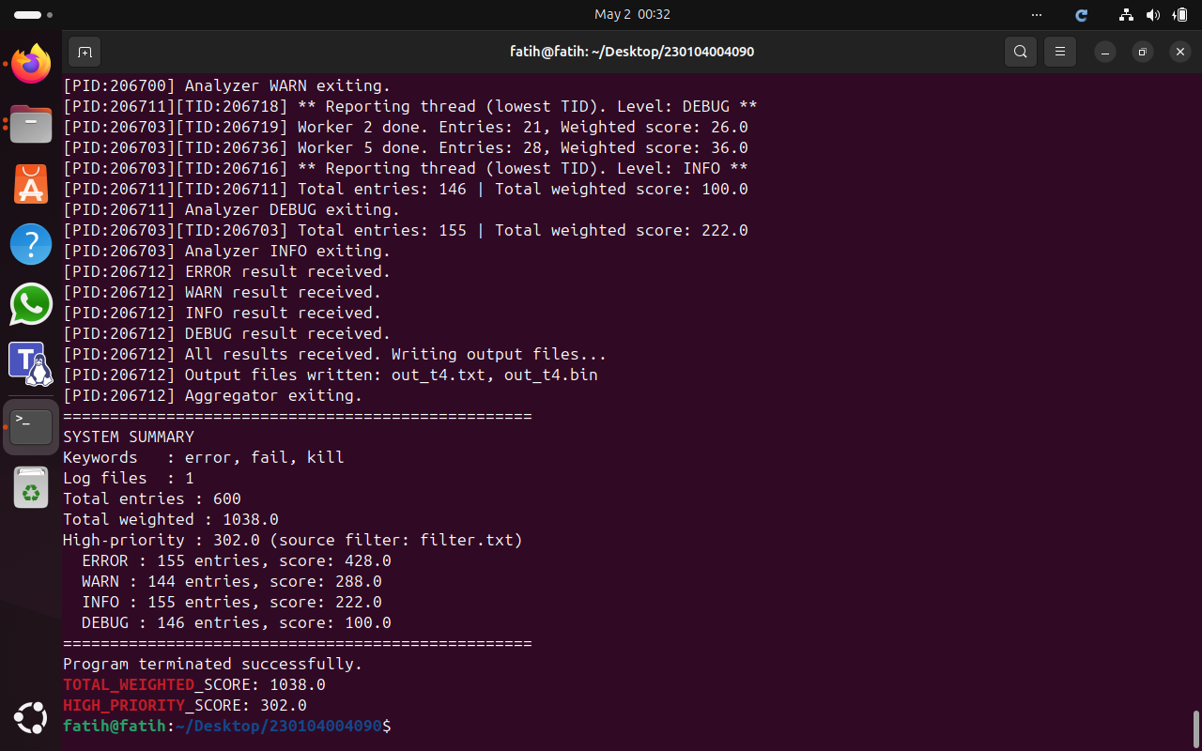

Test 5 — No Priority Matches
Uses an empty filter file. HIGH_PRIORITY_SCORE must be 0.0 and the program must not crash.
echo "" > empty_filter.txt && ./analyzer -c basic.conf -f empty_filter.txt -k "error,fail,kill" -t 2 -w 2 -a 16 -b 16 -d 8 -T 5 -o out_t5.txt -O out_t5.bin && grep "HIGH_PRIORITY" out_t5.txt
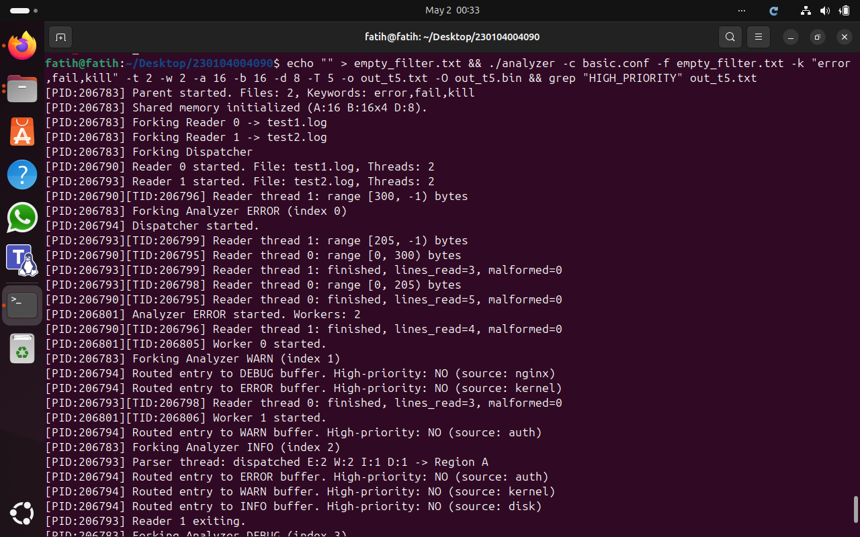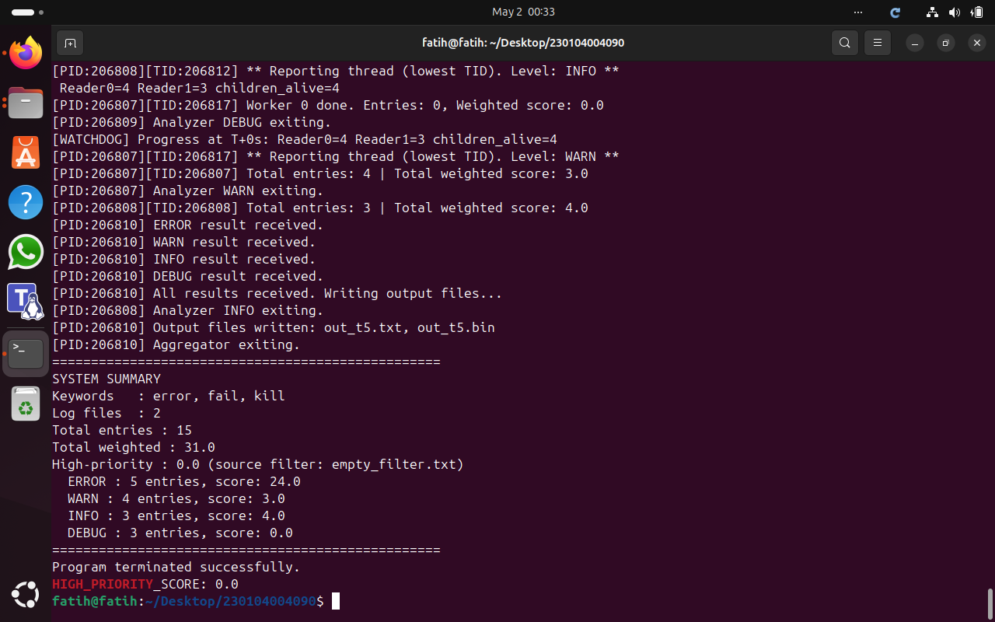

Test 6 — Valgrind
Checks for memory leaks and errors. Expected: 0 errors, 0 leaks, all heap blocks freed.
valgrind --leak-check=full --error-exitcode=1 ./analyzer -c basic.conf -f filter.txt -k "error,fail,kill" -t 2 -w 2 -a 16 -b 16 -d 8 -T 5 -o out_t6.txt -O out_t6.bin 2>&1 | tail -20

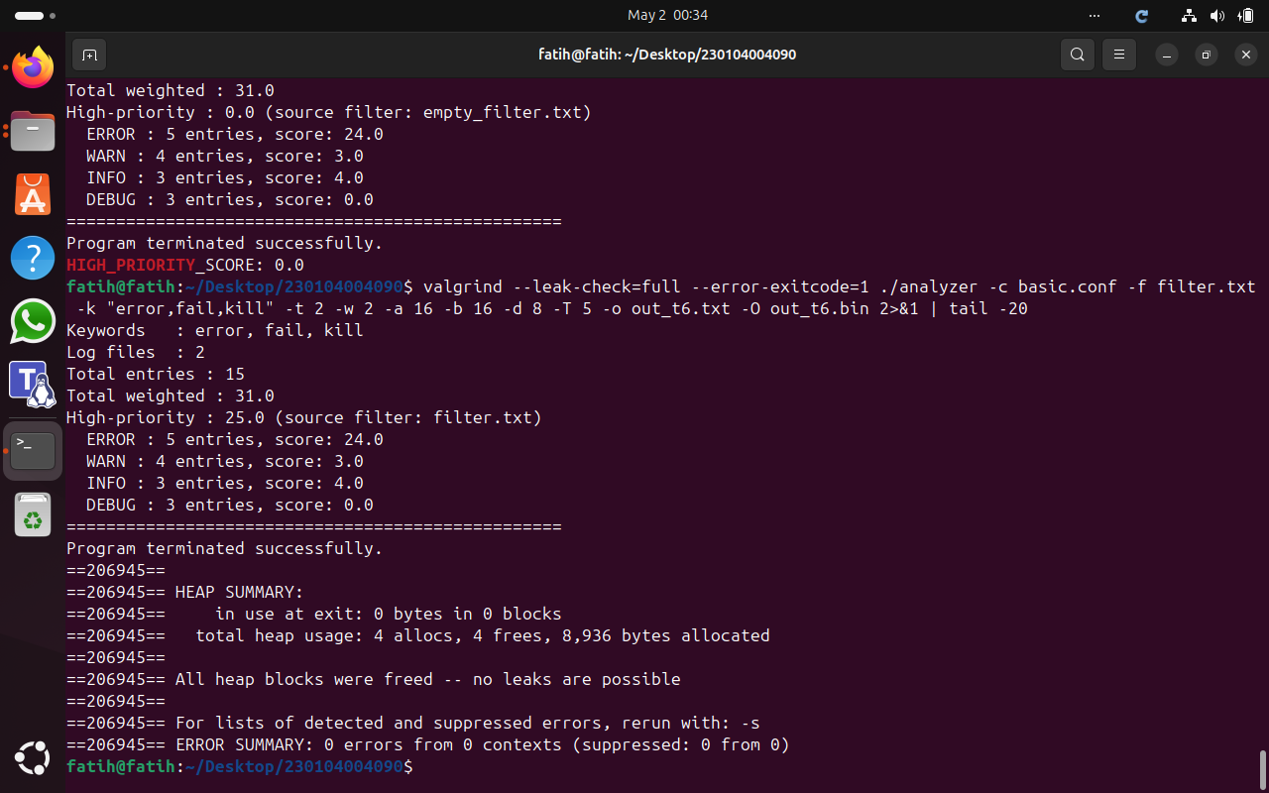

Test 7 — Ctrl+C Handling
Verifies no zombie processes and no orphan shared memory segments after SIGINT.
./analyzer -c large.conf -f filter.txt -k "error,fail,kill" -t 1 -w 1 -a 4 -b 4 -d 2 -T 30 -o out_t7.txt -O out_t7.bin &

sleep 2 && kill -INT $! && sleep 6 && ps aux | grep defunct | grep -v grep || echo "No zombies" && ipcs -m
